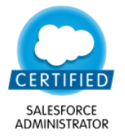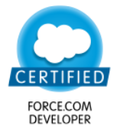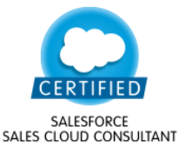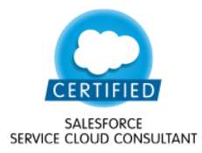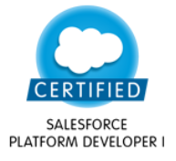

**Srikanth Mallipeddi**

**Mobile:** +91 8143392759

**Email:** sri.mallipeddi17@gmail.com

**Summary**

Software Engineer with 4+ years of experience in analysis, design, development, testing and implementation of various Force.com applications.

**Experience**

Salesforce Developer

October 2014 to Feb 2016 as a freelancer

Salesforce Developer March 2016 to Current

Keste – Hyderabad, Telangana, India

**Technical Highlights**

* Expertise in developing Sales applications on Force.com platform
* Developing and customizing applications within Salesforce using Apex, Visualforce and Triggers
* Developed pages on Community based on Lightning. Ability to develop applications and components in Lightning
* Proficient in developing integrations between Salesforce.com using REST API.
* Responsible for designing pages for Mobile using Salesforce1 application. Can work on different web based technologies like HTML, CSS and Java Script.
* Good idea on performing Deployments using Change sets, Eclipse IDE and ANT Migration Tool.
* Data Migration using Data Loader, Import Wizard and Talend (ETL Tool).
* Experience in working with Creating field sets and Force.com Sites.
* Good experience in automating Force.com application using Workflow, Approvals, Validation Rules
* Reporting and Summarization of data using Reports and Dashboards.
* Building Dataset, Dataflow, Lense and Wave Dashboards.
* Developing various Lightning components.

**Certifications**

* Salesforce.com certified Administrator(201)
* Salesforce.com certified Platform App Builder
* Salesforce.com certified Sales Cloud Consultant
* Salesforce.com certified Service Cloud Consultant
* Salesforce.com certified Platform Developer I
* Salesforce.com certified Platform Developer II(1st level cleared)

**Representative Engagements/Projects**

**Wave Analytics Implementation:**

We create dashboards, lenses, data sets by using WAVE. Represent sales of Optical for different regions in different season measure by using WAVE Dashboard

**Sales Cloud Implementation for a Retail Organization:**

The Retail Application designed to meet the needs of retailer. Retail CRM solution help Retailers of all sizes increase revenue and gain a competitive advantage on our new generation integrated CRM platform. It helps to track the customers, Distributors, Revenue by Outlets and Orders with respective to retailer.

Developed Visualforce pages to capture Orders and created reports to give a complete overview of sales by outlets and Sales Persons

**Data Migration for an Organization from a Legacy System**

I have created data migration jobs to transfer data into Salesforce from a legacy system. An Open Source ETL tool is being used to transfer the data between 2 environments. The project involves a testing Stage followed by UAT and final round of migration to Production environment.

**Project Management Tool**

This is an Enterprise application developed an application on Force.com Platform to meet the needs of Project Management among different departments in the organization.

Created Visualforce pages and Triggers to automate the Project Process.

Created charts based on Google APIs which shows the summarized information of tasks.

Created Gantt Charts which helps in Analyzing the Task Start and End Dates, Status and Type of Tasks for the specific project

**Recruiting Application for a HR Consultancy**

The Recruiting application keeps track of all the candidates, Jobs and Companies. I have developed a search engine for the Candidates to search jobs and for the partners to search Candidates based on filters. The filters include Candidate Experience, qualifications, Roles and responsibilities.

**Key Insights**

* Google APIs to display Customer’s on Google Maps and calculate the distance between places.
* Worked on readily available App exchange products which includes Survey Force, Facebook with Salesforce which helps in surveying customers after service.
* Developed a Parser routine which helps is parsing the email and creating Leads in Salesforce.

**Education**

* Post Graduated (M.C.A) in the year 2014 from Gudlavalleru Engineering College under Jawaharlal Nehru Technological University (JNTU), Kakinada, Andhra Pradesh, India.

**Awards**

Received Best contributor Award in the month of March, 2017.

**Declaration**

I hereby declare that the information furnished above is true to the best of my knowledge.

**PLACE: HYDERABAD (SRIKANTH MALLIPEDDI)**